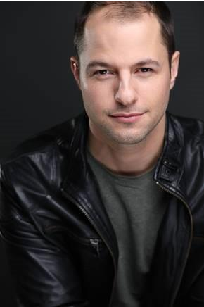
Tyler Joseph

Hair: Brown Eyes: Brown Height: 6’2” Weight: 175

TELEVISION
BLUE BLOODS (S.7 E.11)

FILM
CUPID’S CUPCAKES

MONTROSE AVENUE THE CONTESTANTS
CONVERSATIONS IN APT 3 MILKWATER
WE’RE GONNA BLOW UP THE MOON

OFF-BROADWAY WICKED FROZEN

THEATER GRAND HOTEL
PYRAMID EFFECT
ELEANOR DESCENDING A STAIRCASE THE FATHER (STRNDBERG)
THE GOOD LIFE WRONG NUMBER CARNIVAL OKLAHOMA!
SHOW BOAT

Co Star

Lead

Lead Lead
Supporting Lead Supporting Supporting Lead

Kris / Nice Guy Kris

Rohna Steve Clerk Happy
Tommy Shay Dan
Marco the Magnificent Will Parker
Frank Schultz

CBS, Dir: Alex Chapple

Dir. Gwynedd Vetter-Drusch
Dir. Jessie Ruane Dir. Timothy Blank Dir. Megan Channell Dir. Morgan Ingari Dir. Andrew Yontz

St. Luke’s Theatre

Finger lakes, Dir. Brett Smock Williamstown Theatre Festival Williamstown Theatre Festival New York, NY, Dir Robert Greer New York, NY, Dir. Tom Paulino New York, NY, Gallery Players Austin, TX
Dir. Jeremy Benton
Fort Meyers, FL

COMMERCIALS, VOICEOVERS & INDUSTRIALS (List available upon request)

EDUCATION & TRAINING Western Kentucky University Williamstown Theatre Festival Voice
Acting Dance
On-Camera

BFA - Performing Arts (Musical Theatre) Apprentice 2018
Tracey Moore, Paul Lincoln, Chad Johnson Katie Flahive, Matthew Corozine, Tracey Moore Jeremy Benton, Scott Thompson, Lisa Long
Kim Graham, CSA, Ted Brunetti, Danish Kashani

SKILLS
Dialects: Southern, British, Irish, Australian; Acoustic Guitar; Stage Combat; Backflips; Baseball; Elmo Impersonation

